All data dictionary locations: [Data Dictionaries](https://cdc.sharepoint.com/:f:/r/teams/NCEZID-DHQP-SP-Post-Acute-Care/Shared%20Documents/General/Deputy%20Team%20Lead%20folder/Data%20Manager%20Folder/PAC%20Team%20Data%20Dictionary/Data%20Dictionaries?csf=1&web=1&e=uwP22o)

**Step 1:** Find orgID that under SVH

\\cdc.gov\project\CCID_NCPDCID_NHSN_SAS\Data\work\_Projects\LTC\COVID-19\SAS datasets

Dataset name: *covid19_ltc_facility*

Generate a list of OrgID that under SVH

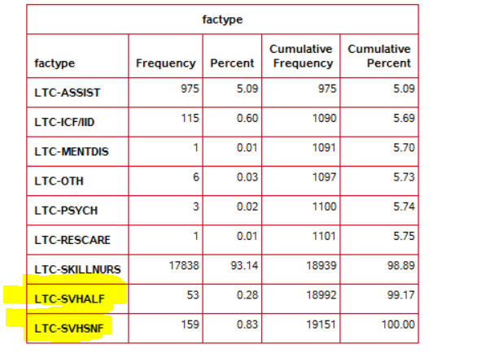

**Step 2:** Locate residents vax records within these SVH

\\cdc.gov\project\CCID_NCPDCID_NHSN_SAS\Data\work\_Projects\Vaccination\Datasets\Current

Dataset *name*: ltccovid19_c19_res_vacc_event

Step 1.1 : limit to OrgID under SVH

Step 1.2 Shrink all same records with different surweekstatus down to one (using the most recent record) ***THIS IS DEDUPLICATION OF WEEKLY SURVEY DATA***

Step 1.3 Proc sql the most useful vaxed population dataset: OrgID, resrecID, gender, dob, ethnicity, dose1date, dose1mfg, dose2-7

Goal: giving us all residents who have been vaccinated in the SVH, each resident has a row of their demographic data and vaccination records 2-7

**Step 3:** Event data

\\cdc.gov\project\CCID_NCPDCID_NHSN_SAS\Data\work\_Projects\LTC\COVID-19\SAS datasets\Weekly

**Dataset name:** ltccovid19_svh_event (include both staff and residents)

Step 3.0 limit to records only with “resrecID”

Step3.1 identify the most recent 5 events for each “resrecID”, keep orgID, dob, gender and ethnicity for all the “resrecID”

Step 3.2 Long format to wide format transpose with important variables: eventDate_1-5, eventID_1-5, symptomatic_1-5, C19Death_1-5

**Step 4:** Left Merging event data (small) to vax data (large)

**Step 5:** Add in admission and discharge dates (tell us who can be included in the study period)

\\cdc.gov\project\CCID_NCPDCID_NHSN_SAS\Data\work\_Projects\Vaccination\Datasets\Current

Dataset *name*: ltccovid19_c19_res_vacc_event

Variables: resAdmitDate, resDischDate

Goal: generate resadmitdate1, resdischdate1, …... resadmitdate5, resdischdate5